PROFILE
Name | : | Ms. K. Rajeswari | 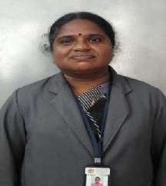
Designation | : | Assistant Professor
Department | : | Mathematics
Educational  Qualification | : | M.Sc., M.Phil., SET., (Ph.D)
Subject of Interest | : | Fuzzy Mathematics
Publications | : | International:  - Examination Result Analysis using Fuzzy Matrix, International Journal of Innovative Research in computer and communication Engineering, Vol. 4, Special Issue 5 ISSN: 2320-9801 (on line) October 2016, pp :6 – 8.  - Effective Completion of Typewriting Examination- Using Fuzzy Matrix in International Journal of Applied Engineering Research, ISSN 0973-4562,Volume 4, 2019(Special issue).
National:
1. Impact of pre requisites in Engineering Mathematics a fuzzy approach” in Indian Journal of Scientific Research,
Vol. 4, Issue 1, May 2017,pp:340- 343.
Google Scholar Link | : | https://scholar.google.co.in/citations?hl=en&user=DO4bh18AAAAJ

